1336 Sherman Dr., Unit C  Longmont, CO 80501-6174 | 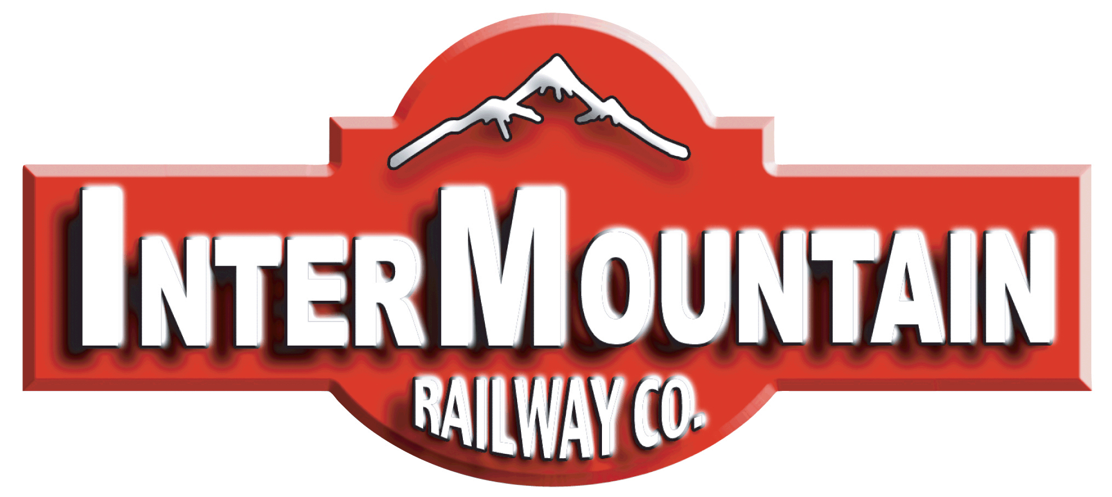 | Phone: (303) 772-1901  Fax: (303) 532-2352
intermountain@intermountain-railway.com www.intermountain-railway.com
DCC OPERATORS GUIDE

Default DCC Address for All Locomotives: 3 (no leading zeros)
Decoder Reset: CV8 = 8

Thank you for your purchase of the InterMountain Railway Company N scale F7A and/or F7B locomotive(s). These locomotives are equipped with either an ESU LokPilot 5 DCC Next18 non-sound decoder OR an ESU LokSound 5 DCC Next18 sound decoder. Both versions are ready to run on DCC out of the box. This guide directs you through basic operational and decoder functions for DCC operation. More in-depth information is available on our website in the DCC Assistance section. Should you have any questions that are not answered in this guide or online, please feel free to contact InterMountain at the contact information listed above.

Operating your N Scale F unit(s)
We do not recommend operating the decoder equipped version of the N scale F units on analog DC track power. If you do not want to invest in a DCC system, please purchase the DC only version of these F units which operate on analog DC the same way as other analog DC locomotives. If you decide later to upgrade to DCC, your locomotive can be easily upgraded to DCC or DCC with sound without soldering. Contact us for more information.

DCC Non-Sound Decoder Operation
The non-sound DCC equipped locomotive responds to address 3 (no leading zeros) out of the box. Place it on your track, choose a direction, and increase the speed on your DCC throttle. The locomotive should move in the direction your throttle is set for. The locomotive lighting is controlled by various function keys. Please see the table on the following page for the functions available in the non-sound decoder. Please verify that all lighting and motion is working properly before making any programming changes to the decoder. If you should have any issues, try a decoder reset CV8 = 8.

DCC Sound Decoder Operation
The DCC sound equipped locomotive responds to address 3 (no leading zeros) out of the box. Upon placing your locomotive on the track, you will not hear any sound. You must press the 8 key (Function 8) on your DCC throttle to get the locomotive's prime mover started. As the prime mover is starting, your locomotive will not move even if you give it a speed command. A prototype locomotive cannot move until it is fully started and your model simulates this! After the prime mover settles into idle (10-20 seconds), you can now give it a speed command, hear the prime mover throttle up, hear the brakes release and watch it slowly move. If you reduce the speed to 0, the brake squeal activates as the locomotive comes to a stop. The table on the following page lists all of the lighting and sound functions available in the sound decoder. If you should have any issues, try a decoder reset CV8 = 8.

The F8 function key operation can be changed to allow track power to start the prime mover by setting CV32 to 3 FIRST, and then CV403 to 32. (In Decoder Pro CV16.3.403 = 32). CV16.3403 default = 16. A prototype locomotive’s horn and bell can still be operated with the prime mover shut-down as long as enough air is available. The LokSound decoder operates in just this way!

Setting the Decoder Address
After you have verified that your locomotive operates properly on address 3, you'll want to give it an address other than 3. The decoder can accept any address from 1 to 9999. Note that Digitrax systems can only set and operate addresses from 1 – 9983. Any address from 128 and above is considered by most DCC systems as a long address. If you want an address between 1-127, set it as a short address. Refer to your DCC System's manual for step-by-step guidance as to how to do this. Once you have set the new address, verify that all lighting and motion works properly before proceeding to any other programming. A guide for Digitrax DCS52 users is available on our website in the DCC Assistance section.

Full Throttle Features
Drive Hold – Activate with Function 9 in both the sound and non-sound units. This allows you to throttle the prime mover sound up or down while your locomotive maintains a constant speed. This helps to simulate pulling heavy “loaded” cars working independent of BEMF for better realism. It's like having custom momentum at your command!

Independent Brake – Turn on Function 10 to set the brakes while moving. Turn it OFF to release the brakes!

These are the most common two Full Throttle Features. More features are explained below the Function Table on the next page.

Default DCC Decoder Function Table

Function Key | DCC Sound N F7A & F7B | DCC Non-Sound N F7A & F7B
F0 Fwd / Headlight | F7A Front Headlight (Lower if dual headlights, upper if single) | F7A Front Headlight (Lower if dual headlights, upper if single)
F0 Rev / Headlight | Rear Headlight | Rear Headlight
F1 / Bell | Bell (Steel Bell by Default) | N/A
F2 / Horn | Playable Air Horn (Leslie Dual A125 - A200 by Default) | N/A
F3 | Coupler | N/A
F4 | Dynamic Brake | Dynamic Brake Logic (use when operating with a sound unit)
F5 | F7A Number Boards | F7A Number Boards
F6 | F7A Upper nose MARS Light (if dual headlights) | F7A Upper nose MARS Light (if dual headlights)
F7 | Headlight / Rear Light Dimmer | Headlight / Rear Light Dimmer
F8 | Prime Mover Start-up / Shut-down (mute if moving) | Virtual Drive Sound (use when operating with a sound unit)
F9 | Drive Hold | Drive Hold (use when operating with a sound unit)
F10 | Independent Brake | Independent Brake (use when operating with a sound unit)
F11 | Radiator Fan | N/A
F12 | F7A Front Ditch Lights (if applicable) | F7A Front Ditch Lights (if applicable)
F13 | Flange Squeal (when moving) | N/A
F14 | Ratchet Hand Brake | N/A
F15 | Isolation Switch | N/A
F16 | Turn Air Dryer on Shutdown OFF | N/A
F17 | Brake Set / Brake Release | N/A
F18 | Sanding Valve | N/A
F19 | Short Air Let Off | N/A
F20 | Compressor | N/A
F21 | Air Dryer | N/A
F22 | Cab Door | N/A
F23 | Engine Compartment Doors | N/A
F24 | Reverser Center | N/A
F25 | Load Mode – (F15, F24, F26, F27, F28 must be OFF!) | Load Mode (use when operating with a sound unit)
F26 | Manual Notch UP – F28 must be turned ON First! | N/A
F27 | Manual Notch DOWN – F28 must be turned ON First! | N/A
F28 | Manual Notching Logic On – Use F26 and F27 to notch up/down | N/A
F29 | Shutters Open / Closed | N/A
F30 | Automatic Brake | Automatic Brake Logic (use when operating with a sound unit)
F31 | Fade Out Sound | N/A

“Isolation Switch” Mode on F15 while Stopped:
Pressing F15 while stopped will lower the prime mover and lock the motor. F15 must be turned off to begin moving.

"Reverser In Center Position": Pressing F24 while stopped locks the motor so you can throttle through the notches like the prototype in neutral. F24 must be turned off to begin moving.

"Run 8" mode: When turning on F26 with F28 off, the prime mover goes to run 8. Turning off F26 returns the prime mover sounds back to normal mode.

"Coast" mode: When turning on F27 with F28 off, the prime mover goes to idle for coasting purposes. Turning off F27 returns the prime mover sounds back to normal mode.

Manual Notching: Keep both F26 and F27 OFF before pressing F28 to turn on manual notching. Once F28 is on, use F26 to notch up and F27 to notch down. F26, F27, and F28 must be turned off to return to normal mode.

"Load" mode: When turning on F25 with F15, F24, F26, F27, F28 off, the prime mover goes into load mode. While in load mode, the prime mover will notch up 1 or more notches based on primary load settings in CV104. The throttle notches up using speed instead of requested speed while using the load feature. F25 must be turned off to return to normal mode.

Decoder Reset: CV8 = 8

Sound Volume CV Defaults Table:
Acceleration Rate:
CV 3 Default = 23 (20.61 seconds)
Range: 1-255
Higher Values = Longer Acceleration Time

Deceleration Rate:
CV 4 Default = 23 (20.61 seconds)
Range: 1-255
Higher Values = Longer Stopping Time
--------------------------------------------------

When operating a non-sound locomotive with a sound locomotive, activate function 8 on the non-sound unit so the two locomotives start together.
--------------------------------------------------

Drive Hold and Independent Brake can be used when sound and non-sound locomotives operate together.
--------------------------------------------------

Programming CVs above 255 if your DCC system doesn't allow it:

Set CV96 to the hundreds digit of the CV number you're trying to program.

Set CV97 to the tens and units digit of the CV number you're trying to program.

Set CV99 to the value that you're trying to program.

Example: Set CV275 to 160.
Set CV96 to 2 (hundreds digit of 275)
Set CV97 to 75 (tens and units digit of 275)
Set CV99 to 160 (value of CV275)
Function | CV # | Range | F units
Master Volume Control | 63 | 0-192 | 128
**** SET CV32 to 1 BEFORE CHANGING THE CV's BELOW ****
EMD 16-567C Prime Mover | 259 | 0-255 | 100
Horn | 275 | 0-255 | 128
Bell | 283 | 0-255 | 60
Coupler | 291 | 0-255 | 60
Dynamic Brake | 299 | 0-255 | 90
Air Compressor | 307 | 0-255 | 40
Radiator Fan | 315 | 0-255 | 75
Auto Brake Emergency | 323 | 0-255 | 50
Automatic Brake | 331 | 0-255 | 50
Independent Brake | 339 | 0-255 | 50
Independent Brake Bail Off | 347 | 0-255 | 50
Sanding Valve | 355 | 0-255 | 20
Hand Brake Ratchet | 363 | 0-255 | 90
Cab Door | 371 | 0-255 | 100
Engine Compartment Doors | 379 | 0-255 | 90
Air Dryer | 387 | 0-255 | 70
Air Dyer on Shutdown | 395 | 0-255 | 70
Reverser | 403 | 0-255 | 30
Reverser Center | 411 | 0-255 | 30
Isolation Switch | 419 | 0-255 | 20
Alarm Bell | 427 | 0-255 | 20
Flange Squeal | 435 | 0-255 | 30
Short Air Let Off | 443 | 0-255 | 20
EMD D27 Traction Motor | 451 | 0-255 | 80
Starting Delay | 459 | 0-255 | 60
Manual Notching Logic | 467 | 0-255 | 20
Brake Set / Release Automatic | 483 | 0-255 | 50
Shutters Open / Closed | 507 | 0-255 | 30
**** SET CV32 to 2 BEFORE CHANGING THE CV BELOW ****
Brake Squeal | 259 | 0-255 | 80

Troubleshooting
N scale decoder equipped locomotives require very reliable electrical connections and contacts. If you are experiencing operating issues with your locomotive, the track and/or locomotive wheels might be dirty. Both of these items need to be cleaned thoroughly on a regular basis for reliable operation. Mineral spirits works very well for these tasks as will anything that does not have water in it. Water attracts more dirt and causes micro-arcing which contributes to the track and wheels getting dirty quicker.

DCC in general also requires plenty of power to the rails in all locations. If you have problem areas with any DCC locomotive, it may be beneficial to add more feeder wires in these locations. Items like turnouts and rail joints are never reliable for passing electrical current. Rail joints can be soldered and extra feeders can be wired on sections of track attached to turnouts to ensure reliable power distribution. If temperature expansion and contraction are an issue for your layout, you can leave gaps periodically to allow for track movement. Just be sure to solder feeder wires to the track on both sides of the gap(s).

If the above is not improving the operation of your locomotive, check that a wire hasn't broken off of one side of one of the trucks. If this happens, the wire can be easily soldered back on. The trucks can be removed by pulling down on the ends of the truck, never the side frames.

If you are having programming difficulties remember that ESU LokSound decoders DO NOT require a program track booster! If you have a program track booster in-line between your DCC system and program track, you must bypass it for programming ESU decoders. More programming information can be found on our website under DCC Assistance.

Decoder Reset: CV8 = 8

Horn List
CV163 | EMD 1st Generation Horn Type
0 | Leslie A-125
1 | Leslie A-200
2 | Leslie A-200 #2
3 | Leslie Dual A200
4 | Leslie Dual A125-A200 (Default)
5 | Leslie S-2M
6 | Leslie S-3K
7 | Leslie S-3L
8 | Leslie S-5T
9 | Nathan M-3
10 | Nathan M-3H
11 | Nathan M-5
12 | Nathan P-5-OC
13 | Nathan P-5-R24-OC
14 | Nathan P-3-OC
15 | Nathan P-3-R4-OC
16 | Nathan P-5A-OC
17 | Wabco E-2

Bell List
CV164 | EMD 1st Generation Bell Type
0 | EMD 8004156 Bronze Bell 011 (Default)
1 | EMD 8475495 Steel Bell 007
2 | EMD 8004156 Bronze Bell 012
3 | EMD 8475495 Steel Bell 009
4 | EMD 8004156 Bronze Bell 013
5 | EMD 8475495 Steel Bell 010

Brake Squeals
CV165 | 1st Generation Brake Squeal Type
0 | Composition Shoe (Default)
1 | Cast Iron Shoe

Air Dryers
CV166 | EMD 1st Generation Air Dryer Type
0 | GP9 Air Dryer 1 (Default)
1 | GP9 Air Dryer 2
2 | GP8 Air Dryer 1
3 | CF7 Air Dryer 1

Auto Bell:

Many Second and Third Generation locomotives have been fitted with an Automatic Bell that is triggered when the horn is blown. In MANY cases this cannot even be bypassed on modern locos. Before the FRA mandated this feature on new locomotives the bell was of course turned on and off separately. Some locomotives were delivered with a manual bell and have been converted to an automatic bell.

We realize that not every loco had this feature. As such there is an option to turn the feature on and off. The default in the InterMountain F7 is OFF.

To turn the feature ON - Auto Bell ON:

1. ADD the Auto bell sound slot from the function mapping chart
CV31 = 16, CV32 = 8
----------------------
CV311 = 12

2. Change the sound configuration of the Auto bell sound slot
CV31 = 16, CV32 = 1
----------------------
CV287 = 1

To turn the feature OFF - Auto Bell OFF:

1. Remove the Auto bell sound slot from the function mapping chart
CV31 = 16, CV32 = 8
----------------------
CV311 = 4

2. Change the sound configuration of the Auto bell sound slot
CV31 = 16, CV32 = 1
----------------------
CV287 = 0

Auto Bell Timer
CV169 | Amount of Time Bell Plays After the Horn (¼ second segments)
4 | 1 second
8 | 2 seconds
12 | 3 seconds
16 | 4 seconds
20 | 5 seconds (Default)
ETC... | ETC...

Track Power DOES NOT need to be interrupted after making a change to CVs 163-169 listed on this page.

Decoder Reset: CV8 = 8

SHELL REMOVAL INSTRUCTIONS
The locomotive shell for F7A units can be easily removed by first unscrewing the front coupler and pulling it out. The rear coupler does not need to be removed. Then hold the nose and rear of the body shell between your thumb and finger. A sharp shake motion towards your other hand should release the die-cast chassis/drive into your other hand.

For the F7B units, the couplers DO NOT need to be removed. Hold the front and rear ends of the body between your thumb and finger. A sharp shake motion towards your other hand should release the die-cast chassis/drive into your other hand.

If the shell is tight, spreading it in the center with both hands and shaking will help release the chassis. Do this over your workbench or table so if the die-cast chassis releases quickly, it does not fall to the floor. It likely will not release quickly on its own. You can pull on the die-cast once you can access it. Try to pull the shell off as evenly as possible.
NEVER PULL ON THE TRUCKS FROM THE SIDE!!

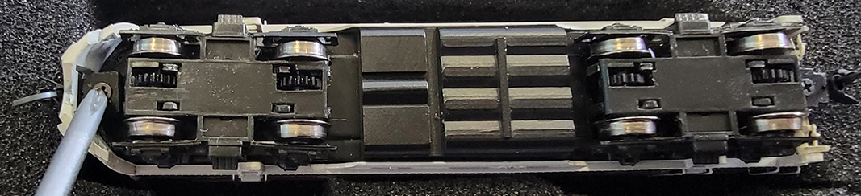
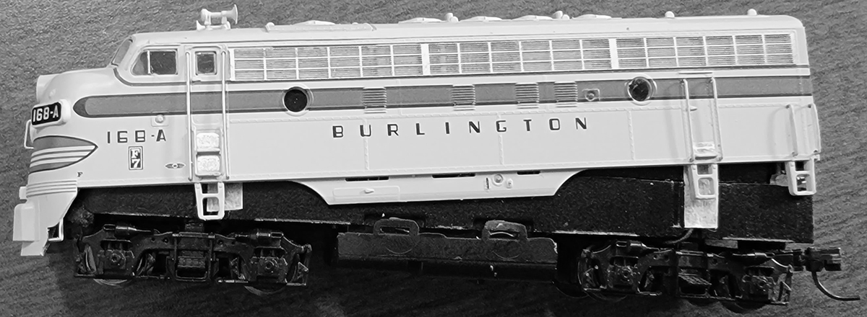

Once the shell is off you will see the DC Jumper board, the LokPilot Micro decoder, or the LokSound Micro decoder on top of the main motherboard depending one which version you've purchased. If you need to remove the board or decoder for any reason, it can be simply snapped off of the main motherboard. To re-install, line up the socket on the decoder with the socket on the main motherboard and press down on top of and towards the rear end of the decoder to seat it in the socket. The decoder can only be installed one way. You may or may not hear/feel the decoder snap in.

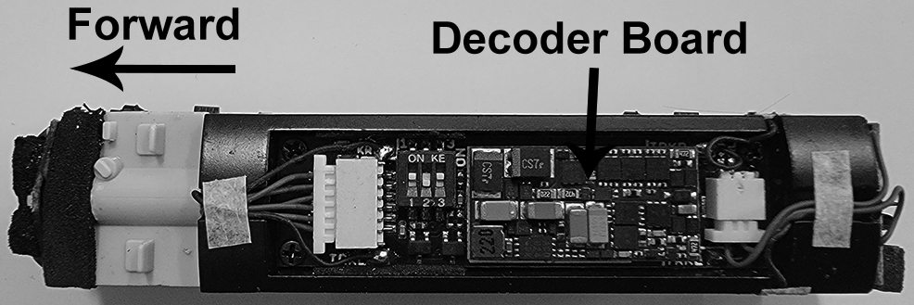

There are no user serviceable parts on the decoder. If it should fail for any reason, it will have to be returned to InterMountain for replacement. Contact us for more information should you need a replacement decoder.

The speaker for the sound equipped units sits inside a black plastic housing inside a cavity under the fuel tank. The speaker and black plastic housing are one unit which can be removed from the die-cast cavity if necessary. The speaker itself cannot be removed from the black plastic housing without doing permanent damage to the speaker!

DO NOT attempt to remove the speaker from the black plastic housing.
Damage to the speaker in this manner is NOT covered under warranty!

MAINTENANCE TASKS
Your InterMountain N scale F7 locomotive is designed to provide hours of enjoyment with little or no maintenance. On occasion the drive gear mechanism should be lubricated. Utilize a plastic compatible lubricant such as Labelle® 107 Oil. To lubricate your locomotive place a few drops on the gears of the drive mechanism. Only a small amount is required.

Service Needs: Although rare, at some time you may require service for your locomotive. Please contact InterMountain Railway Company by email, intermountain@intermountain-railway.com, or by phone, 1-800-472-2530, whenever you have a question or need a repair.

Resetting the decoder solves 95% of the decoder
related issues we handle. Decoder Reset: CV 8 = 8

